**Loan Portfolio Management for Champions Bank**

**Course:** ISQS 6338: Database Concepts

**Professor:** Benjamin (Ben) Mitchell, MISM, Ph.D.

**Team Members:**

Berihun Mekonnen, Praveen Hariharasubramanian, Vinod Babu Palani

**Team:**

Group 11 - Team SWAT

**Email ID:**

[berihun.mekonnen@ttu.edu](mailto:berihun.mekonnen@ttu.edu), [praveen.hariharasubramanian@ttu.edu](mailto:praveen.hariharasubramanian@ttu.edu), [vinod-babu.palani@ttu.edu](mailto:vinod-babu.palani@ttu.edu)

|  |  |  |
| --- | --- | --- |
| **S.No** | **Contents** | **Page** |
| 1 | Executive Business Summary | 3 |
| 2 | Problem Statement | 3 |
| 3 | Project Description | 3 |
| 4 | Business Value | 3 |
| 5 | Project Assumptions | 4 |
| 6 | Project Boundaries | 4 |
| 7 | Objects in the Model | 4 |
| 8 | Conceptual Model | 5 |
| 9 | Logical Model | 6 |
| 10 | Entity Relationships | 7 |
| 11 | Physical model | 8 |
| 12 | SQL statements | 9 |

1. **Executive Business Summary:**

This Business case is a proposal to create relational database for Loan department of Champions Bank. The database entails all loan application and loan portfolios linked to customers with loans and potential customers for future loan products.

The goals are:

* Identify Customers defaulting on loans
* Notification management to alert customers on due dates for payments
* Locate potential customers for banking products
* Evaluate eligibility of customers for loan
* Track the status of loans from applied, in-progress, backlog through closed.
* Manage the overall revenue generation of Loan section in the bank.

1. **Problem Statement:**

Champions Bank is 2 years old bank serving more than 100,000 customers across US. Recently they have launched various loan products for the benefit of customers. Currently, Bank is relying on spreadsheets and paper works to manage the loan section which is very tedious, time consuming and inaccurate. An optimum solution is required to streamline the loan process efficiently, to serve the customers better and to identify bad loans.

1. **Project Description:**

This project is aimed at creating a relational database for Loan management with Loan information, customer attributes, transactional information and credit score. ER model and logical model for the database will be created. Based on this, actual physical tables with appropriate columns, keys and indexes are to be created. Relationship between tables is to be identified and established. Database model will then be tested with testing data to check the effectiveness of functionalities and is to be validated by Business. Below is the Project timeline and materials.

|  |  |
| --- | --- |
| **Business Owner** | Champions Bank |
| **Data Owner** | Champions Bank |
| **IT Members** | Berihun Mekonnen, Praveen Hariharasubramanian, Vinod Babu Palani |
| **Project Timeline** | 17-OCT-2017 to 05-DEC-2017 |

1. **Business Value**

* Identify loyal customers for selling bank products
* Track and manage Customers defaulting on loan
* Revenue generation from loan section of the bank
* Understand the sale trends of Loan products

1. **Project Assumptions**
2. All customer bank accounts linked to customer’s SSN.
3. Credit Score is calculated and fed to database through external module.
4. Only Individuals are considered as customers. Institutional Customers are not considered.
5. Loan officers work only in one branch and are more related to loan applications than customers.
6. **Project Boundaries**

The primary goal of the database management system is to compute revenue generated by the bank through Loans, notify loan defaulters and identify prospective customers for the loan products.

1. **Objects in the model**
2. **Customer** - ‘Customer’ entity has basic customer information including name, address, phone, email and SSN. Each customer will have only one record.
3. **Branch** – ‘Branch’ entity has list of Bank’s branches across the Country. Each branch is uniquely identified through an ID.
4. **FICO Score** – Credit score for the customer’s SSN is fed to this Entity. Each customer has one and only one FICO score
5. **Loan Application** – This Entity details the information provided in loan applications. Each Loan application has a single record.
6. **Loan** – This entity has list of all available loan products in the bank. Each loan product has single record.
7. **Loan Category** – This entity has list of categories under which loan products fall into. Each category is one entry in the entity.
8. **Payment Mode** – Payment modes like Credit card, Debit card, Direct deposit, etc. are listed in this entity. Each payment mode constitutes a record in this entity
9. **Loan Officer** – This entity has details of officer who facilities the loan process for the customer. Each record represents details of one loan officer.
10. **Customer Loan Information** – This entity has information about the approved loan details of the customer including approved limit, start and end date of the loan, loan period and due date for the next payment. Each loan is identified by a unique Loan number
11. **Loan Transaction** – Each transaction made towards a loan is tracked in this entity. Each Transaction has a unique transaction number
12. **Net Asset** – This entity has assets and its values as pledged or mortgaged by the customer for the loan.
13. **Default Loans** – This entity has list of loans defaulted by the customer. It is refreshed every day to update the loan defaults based on due date of the loan’s term.
14. **Conceptual model:**

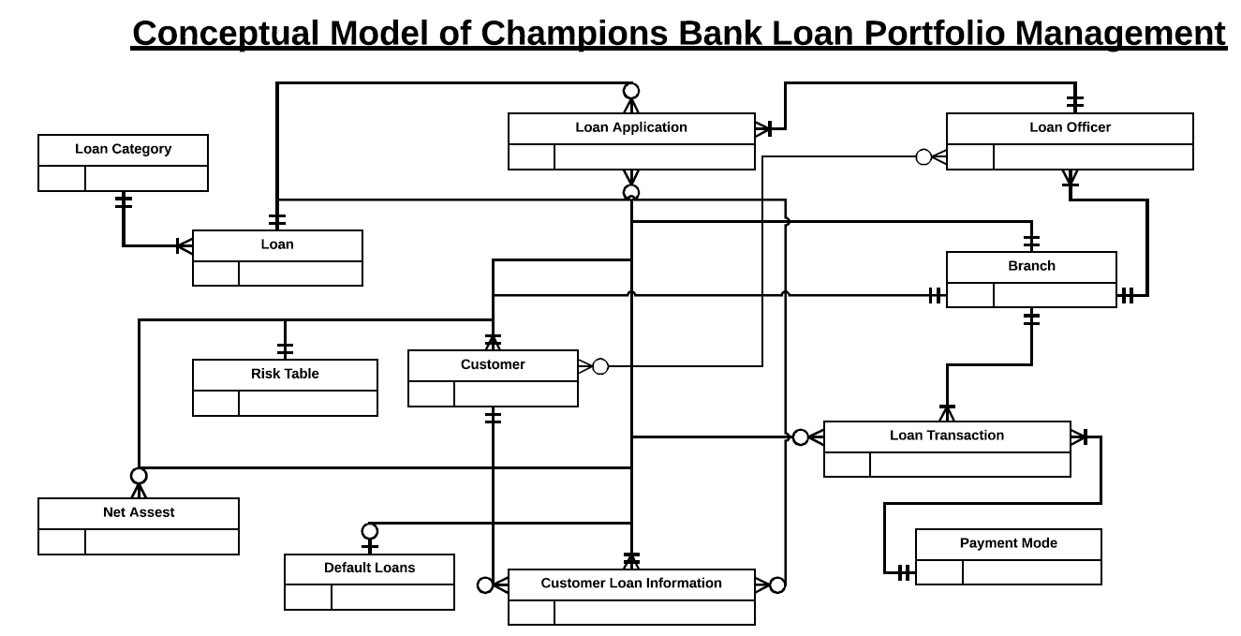

1. **Logical Model:**

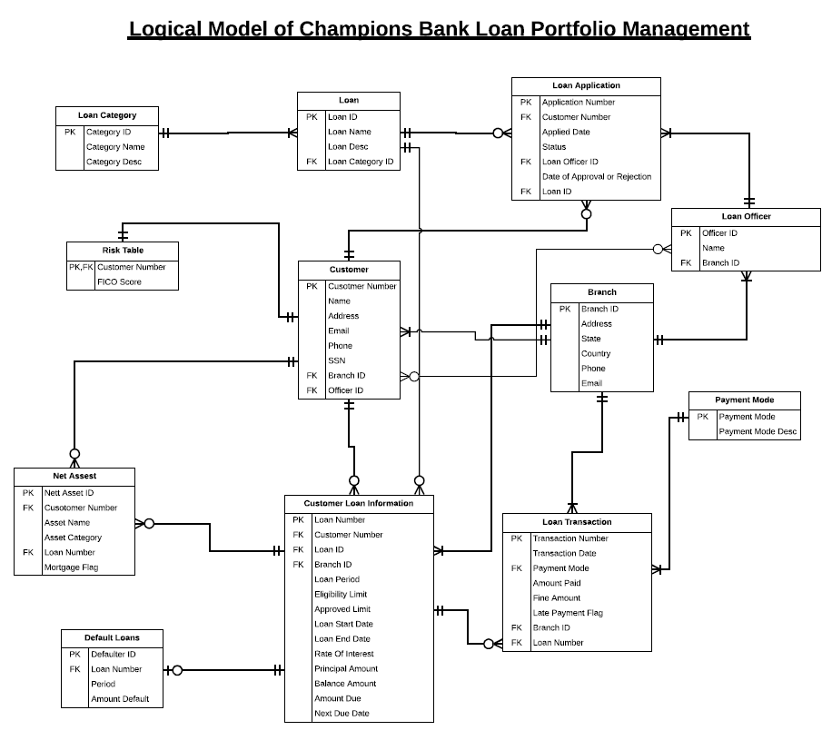

1. **Entity Relationships:**

|  |  |  |  |
| --- | --- | --- | --- |
| **Entity** | **Related to** | **Relation** | **Cardinality** |
| Loan Category | Loan | Each Loan category has one or more Loan products | One to one or Many |
| Loan | Customer Loan Information | Each Loan can be taken by one or many customers | One to zero or Many |
| Loan Application | Each Loan product can have zero or many loan applications | One to zero or Many |
| Loan Officer | Loan Application | Each Loan Officer facilitates atleast one loan application | One to one or Many |
| Customer | Loan Application | Each customer can apply for zero or many loan applications | One to zero or Many |
| Risk Table | Each customer can have only one FICO score | One to One |
| Customer Loan Information | Each customer can have zero or many loans | one to zero or many |
| Net Asset | Each customer can pledge zero or more assets | one to zero or many |
| Branch | Loan Officer | Each branch has one or many Loan Officers | One to zero or many |
| Loan Transaction | Atleast one transaction happens in each branch | One to one or many |
| Customer | Each Branch has atleast one customers | One to one or Many |
| Customer Loan Information | Each Branch has atleast one customers who has taken loan | One to one or Many |
| Customer Loan Information | Loan Transaction | Each Customer Loan can have zero or many Transactions towards loan | One to zero or Many |
| Net Asset | Each Customer Loan can have zero or many assets mortgaged | One to zero or Many |
| Default Loans | Each customer loan shall or shall not be defaulted | one to zero or one |
| Payment Mode | Loan Transaction | Each Payment mode has atleast one transaction | One to one or Many |

1. **Physical Model:**

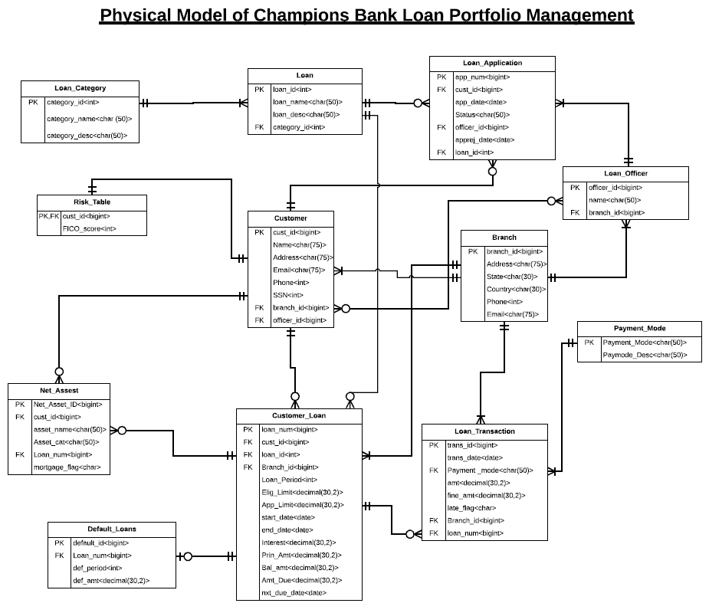

1. **SQL Statements:**

**Table Creation:**

|  |  |  |
| --- | --- | --- |
| **S.No** | **Table** | **SQL** |
| 1 | loan_category | drop table loan_category; create table loan_category( category_id int primary key not null, category_name char(50), category_desc char(50) ); |
| 2 | risk_table | drop table risk_table; create table risk_table( cust_id bigint primary key not null, fico_score int ); |
| 3 | net_asset | drop table net_asset; create table net_asset( net_Asset_id bigint primary key not null, cust_id bigint, asset_name char(50), asset_cat char(50), loan_num bigint, mortgage_flag char ); |
| 4 | default_loans | create table default_loans( default_id bigint primary key not null, loan_num bigint, def_period int, def_amt decimal(30,2) ); |
| 5 | customer_loan | drop table customer_loan; create table customer_loan( loan_num bigint primary key not null, cust_id bigint, loan_id int, branch_id bigint, loan_period int, elig_limit decimal(30,2), app_limit decimal(30,2), start_Date date, end_date date, interest decimal(30,2), prin_amt decimal(30,2), bal_amt decimal(30,2), amt_due decimal(30,2), nxt_due_date date ); |
| 6 | customer | drop table customer; create table customer( cust_id bigint primary key not null, name char(75), address char(75), email char(75), phone bigint, ssn bigint, branch_id bigint, officer_id bigint ); |
| 7 | loan | drop table loan; create table loan( loan_id int primary key not null, loan_name char(200), loan_desc char(200), category_id int ); |
| 8 | loan_application | drop table loan_application; create table loan_application( app_num bigint primary key not null, cust_id bigint, app_date date, status char(50), officer_id bigint, apprej_date date, loan_id int ); |
| 9 | loan_officer | drop table loan_officer; create table loan_officer( officer_id bigint primary key not null, name char(50), branch_id bigint ); |
| 10 | branch | drop table branch; create table branch( branch_id bigint primary key not null, address char(75), state char(30), country char(30), phone bigint, email char(75) ); |
| 11 | payment_mode | drop table payment_mode; create table payment_mode( payment_mode char(50) primary key not null, paymode_desc char(50) ); |
| 12 | loan_transaction | drop table loan_transaction; create table loan_transaction( trans_id bigint primary key not null, trans_date date, payment_mode char(50), amt decimal(30,2), fine_amt decimal(30,2), late_flag char, branch_id bigint, loan_num bigint ); |

**Data insert statements:**

1. **Table: risk_table**

delete from risk_table;

insert into risk_table(cust_id,fico_score) values(797339,629);

insert into risk_table(cust_id,fico_score) values(918275,604);

insert into risk_table(cust_id,fico_score) values(687873,673);

1. **Table: loan_category**

delete from loan_category;

insert into loan_category(category_id,category_name,category_desc) values(1,'Personal loan','Loan for undisclosed purpose with higher risk');

insert into loan_category(category_id,category_name,category_desc) values(2,'Housing loan','Loan for housing with lower risk');

insert into loan_category(category_id,category_name,category_desc) values(3,'Car loan','Loan for car with lower risk');

1. **Table: net_assest**

delete from net_asset;

insert into net_asset(net_asset_id,cust_id,asset_name,asset_cat,loan_num,mortgage_flag) values(4287773,839154,'5000 sq ft Office','Commercial space',3651401,'Y');

insert into net_asset(net_asset_id,cust_id,asset_name,asset_cat,loan_num,mortgage_flag) values(829322,928880,'3BHK apt','Residential space',2443698,'Y');

insert into net_asset(net_asset_id,cust_id,asset_name,asset_cat,loan_num,mortgage_flag) values(5062222,912344,'3000 sq ft Office','Commercial space',2057499,'N');

1. **Table: default_loans**

delete from default_loans;

insert into default_loans(default_id,loan_num,def_period,def_amt) values(1787685,4740459,'48','35000');

insert into default_loans(default_id,loan_num,def_period,def_amt) values(7298403,5397154,'56','13000');

1. **Table: loan**

delete from loan;

insert into loan(loan_id,loan_name,loan_desc,category_id) values(190,'Commercial car loan','Loan for car used for commercial use for a company,firm or enterprise',3);

insert into loan(loan_id,loan_name,loan_desc,category_id) values(347,'Individual house loan','Loan for purchase of house for personal use',2);

insert into loan(loan_id,loan_name,loan_desc,category_id) values(288,'Apartment loan','Loan for purchase of apartment for personal use',2);

1. **Table: customer**

delete from customer;

insert into customer(cust_id,name,address,email,phone,ssn,branch_id,officer_id) values(797339,'Jones Peterson','911 Main Street Hamilton, OH 45011','xurreppyxoffu-3448@yopmail.com',7403058053,554536865,12196536,53427713564);

insert into customer(cust_id,name,address,email,phone,ssn,branch_id,officer_id) values(918275,'Rebecca Briston','555 Cambridge St. Saint Cloud, MN 56301','pexazonne-4844@yopmail.com',6182566912,621147770,29358858,4086644684);

insert into customer(cust_id,name,address,email,phone,ssn,branch_id,officer_id) values(687873,'Phenelope Trunk','753 S. Goldfield Ave. Glasgow, KY 42141','feffavorug-5924@yopmail.com',8722416233,850574492,28763473,43124705505);

1. **Table: customer_loan**

delete from customer_loan;

insert into customer_loan(loan_num,cust_id,loan_id,branch_id,loan_period,elig_limit,app_limit,start_date,end_date,interest,prin_amt,bal_amt,amt_due,nxt_due_date) values(170302181,797339,327,12196536,45,61329,58865,'12/14/2016','8/25/2020',2.5,23668,17359,520,'1/5/2018');

insert into customer_loan(loan_num,cust_id,loan_id,branch_id,loan_period,elig_limit,app_limit,start_date,end_date,interest,prin_amt,bal_amt,amt_due,nxt_due_date) values(179669625,918275,206,29358858,12,71337,45934,'12/11/2016','12/6/2017',1.5,48695,44863,610,'12/10/2017');

insert into customer_loan(loan_num,cust_id,loan_id,branch_id,loan_period,elig_limit,app_limit,start_date,end_date,interest,prin_amt,bal_amt,amt_due,nxt_due_date) values(3651401,687873,380,28763473,16,76485,58165,'11/28/2016','3/23/2018',5.7,36957,32348,505,'12/13/2017');

1. **Table: loan_application**

delete from loan_application;

insert into loan_application(app_num,cust_id,app_date,status,officer_id,apprej_date,loan_id) values(286840181,797339,'10/14/2016','Approved',53427713564,'12/10/2016',327);

insert into loan_application(app_num,cust_id,app_date,status,officer_id,apprej_date,loan_id) values(460271221,919275,'9/3/2016','In processing',43124705505,'11/2/2016',212);

insert into loan_application(app_num,cust_id,app_date,status,officer_id,apprej_date,loan_id) values(163190300,687873,'11/28/2016','Approved',43124705505,'12/11/2016',380);

1. **Table: loan_officer**

delete from loan_officer;

insert into loan_officer(officer_id,name,branch_id) values(53427713564,'Bobbie Carr',12196536);

insert into loan_officer(officer_id,name,branch_id) values(4086644684,'Neil Gonzales',29358858);

insert into loan_officer(officer_id,name,branch_id) values(43124705505,'Bessie Gilbert',28763473);

1. **Table: branch**

delete from branch;

insert into branch(branch_id,address,state,country,phone,email) values(12196536,'504 Magnolia Ave. Fargo, ND 58102','North Dakota','USA',6819473025,'ubebappurr-5504@yopmail.com');

insert into branch(branch_id,address,state,country,phone,email) values(29358858,'991 Boston Drive Dayton, OH 45420','Ohio','USA',6060280611,'maddeffusav-7843@yopmail.com');

insert into branch(branch_id,address,state,country,phone,email) values(28763473,'8636 North 3rd Lane Laurel, MD 20707','Maryland','USA',7343914889,'qalagikyll-7155@yopmail.com');

1. **Table: payment_mode**

delete from payment_mode;

insert into payment_mode(payment_mode,paymode_desc) values('CSH','Cash advance deposit');

insert into payment_mode(payment_mode,paymode_desc) values('CHK','Cheque deposit into bank account');

insert into payment_mode(payment_mode,paymode_desc) values('CRD','Credit Card');

insert into payment_mode(payment_mode,paymode_desc) values('DBT','Debit Card');

1. **Table: loan_transaction**

delete from loan_transaction;

insert into loan_transaction(trans_id,trans_Date,payment_mode,amt,fine_amt,late_flag,branch_id,loan_num) values(1854486486,'10/26/2016','CHK',2990,11,'Y',39957006,170302181);

insert into loan_transaction(trans_id,trans_Date,payment_mode,amt,fine_amt,late_flag,branch_id,loan_num) values(1905402416,'11/27/2016','CSH',3560,0,'N',34232721,3651401);

insert into loan_transaction(trans_id,trans_Date,payment_mode,amt,fine_amt,late_flag,branch_id,loan_num) values(2938528285,'8/2/2017','CRD',3563,0,'N',50835294,2443698);